Jenkins war file Deployment using ansible.
1-First install plugin publish over ssh.
2-set the password-
manage jenkins → configure system-→ Publish over ssh
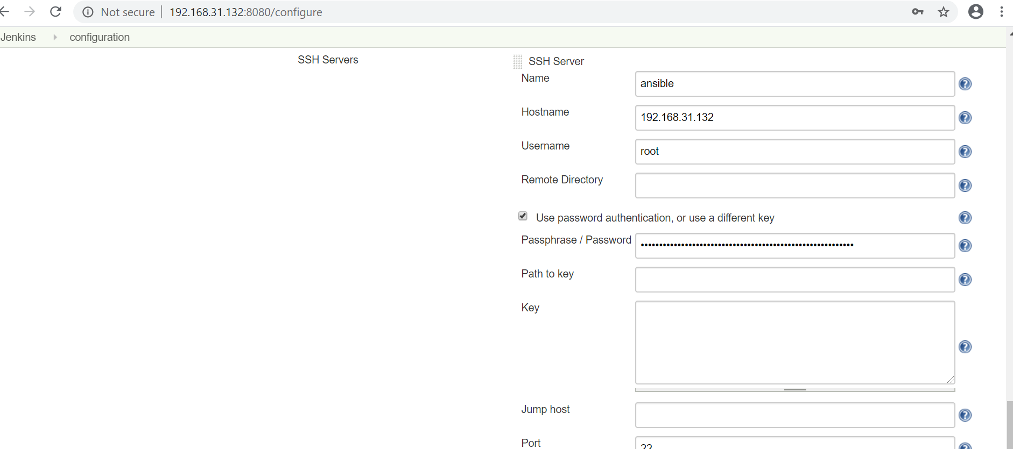

you can also test the setting
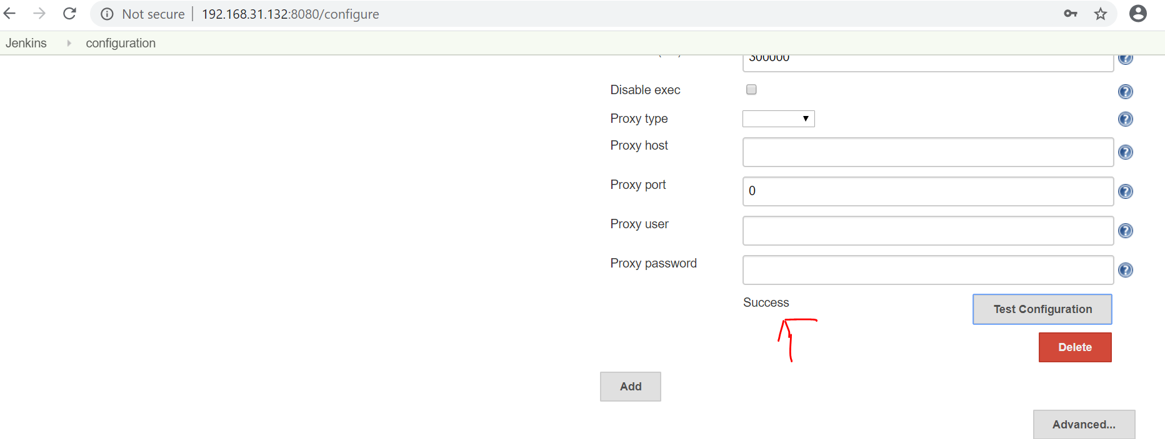
Now server side install ansible and write the below playbook
also add the ssh key from ansible server to tomcat server
ssh-keygen enter enter
ssh-copy-id -i root@tomcatip
[root@localhost home]# cat copyfile.yml
---
- hosts: web
become: true
tasks:
- name: copy war into tomcat server
copy:
src: /var/lib/jenkins/workspace/new_project/target/java-tomcat-maven-example.war
dest: /opt/tomcat/apache-tomcat-8.5.51/webapps/java-tomcat-maven-example.war

3-
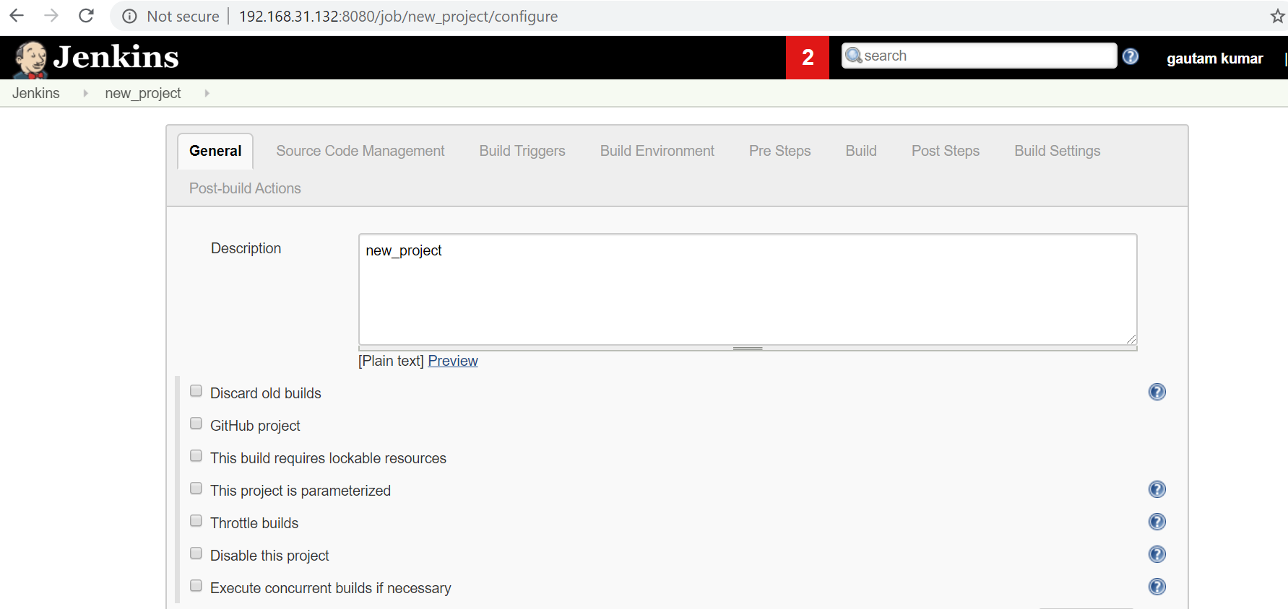
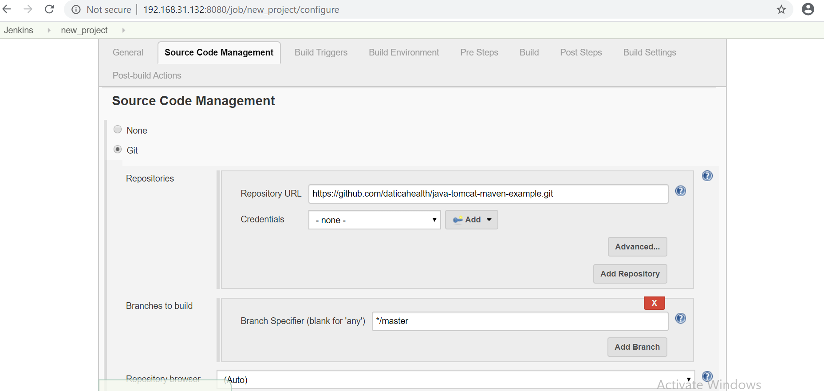
4-

5-

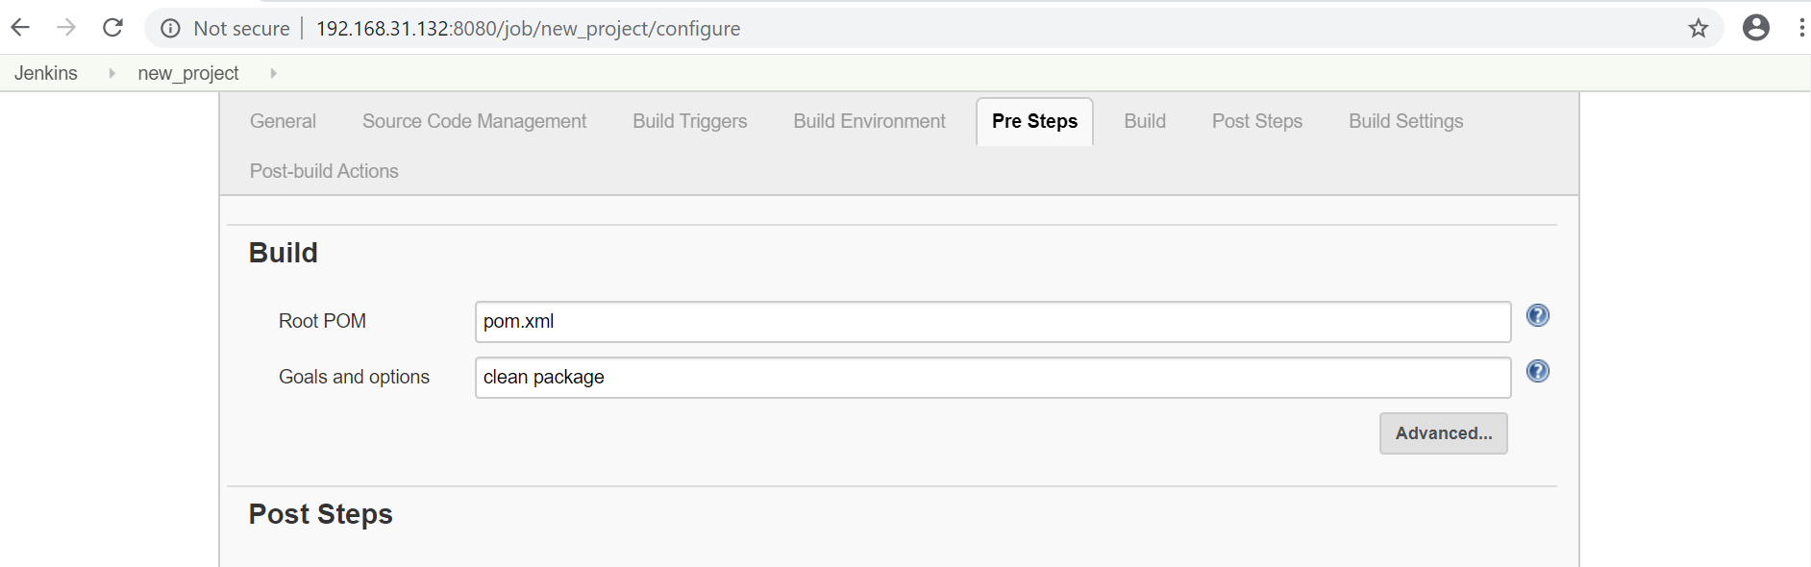
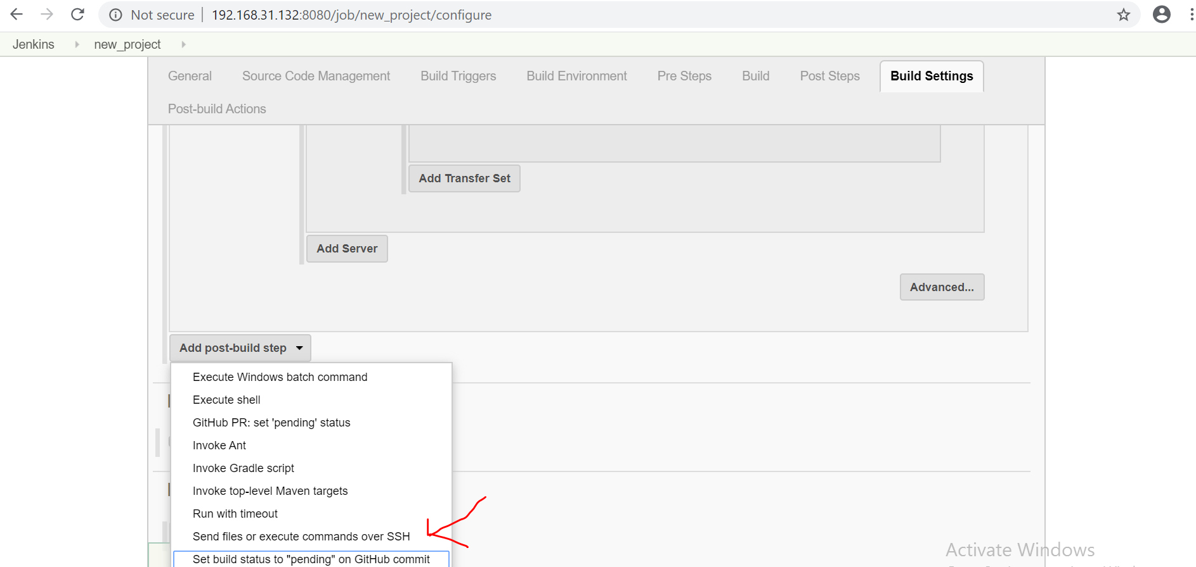
6- here /home/ is the path of my playbook
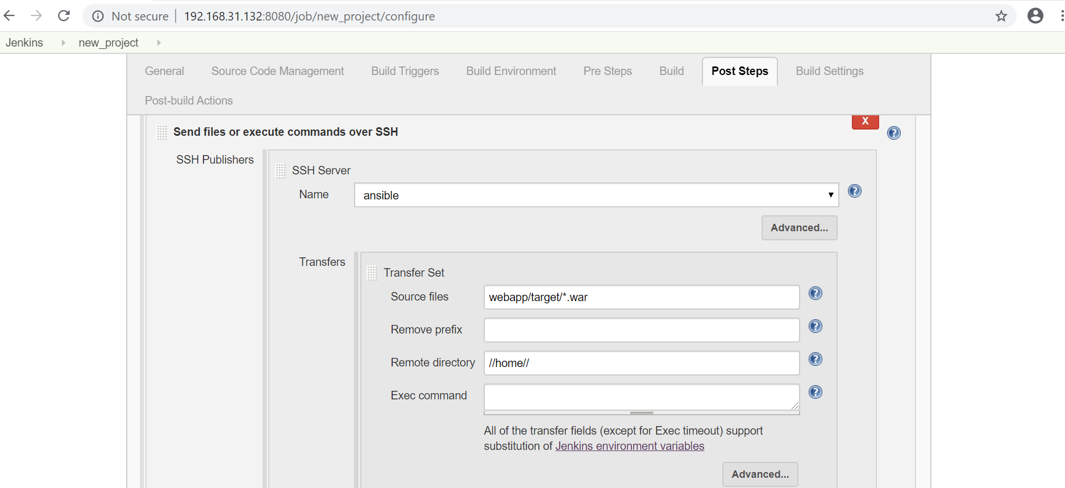
7-execute the command in another publish over ssh
